Age Group Dispensation Request  Please provide as much detail as possible, highlighting the reasons why the player can’t play in their appropriate age group. A minimum of 3 days’ notice must be provided for any requests before a player is due to play and they cannot participate until approval is given. Players given dispensation can play as normal but will be ineligible for individual awards.  Form should be completed and then submitted by the Club to the MWJCA Executive for approval. | 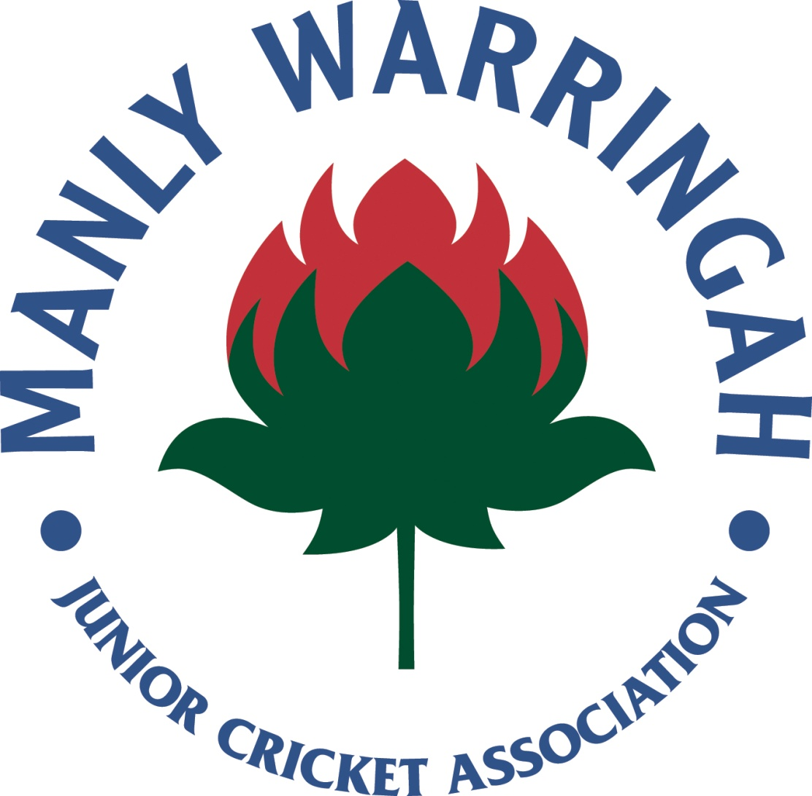

Players Name: |  |  |  |  |  |  |  | Male / Female
Parents Name & Ph. Number:
Club:
Club Contact Name & Ph. Number:
Age Group / Division:
Player DOB: |  |  | No. Months Overage:
Age Group Last Played: |  |  |  |  | Division Last Played:
Season Last Played:
Club Last Played (if different from above):

Statistics (Last season played)
Games Played: |  | Champion Player Points:
Batting Aggregate: |  | Batting Average:
Bowling Aggregate: |  | Bowling Average:

Cricket history (short paragraph including rep selections, squads, etc):

Reason for requesting dispensation for overage player:

